

Ai-Assisted Search Engine Optimization System for Academic Website

CAPSTONE PROJECT REPORT

A Group assignment Report submitted in partial fulfilment of the requirements for the Course of

CSA1701 & Artificial Intelligence

to the award of the degree of

BACHELOR OF ENGINEERING / BACHELOR OF TECHNOLOGY

IN
COMPUTER SCIENCE AND ENGINEERING (BRANCH)

Submitted by
K. Hari Chandana (192411147)
Under the Supervision of
Dr. B. Abirami
SIMATS ENGINEERING
Saveetha Institute of Medical and Technical Sciences Chennai-602105
SEPTEMBER 2026
AI-ASSISTED SEARCH ENGINE OPTIMIZATION SYSTEM FOR ACADEMIC WEBSITE
A. ASSIGNMENT INFORMATION
Particular | Details
Department | CSE
Programme | B. Tech – Artificial Intelligence and Data Science
Course Code & Course Name | CSA1701 – Artificial Intelligence
Academic Year / Batch | 2026
Faculty Name | Dr. Abirami
Assignment Title | AI-Assisted Search Engine Optimization System
Date of Issue | 01/09/2026
Date of Submission | 02/09/2026
Maximum Marks | 100
Bloom's Taxonomy Level | L3 – Apply, L5 – Evaluate
SDG Mapping | SDG 4 – Quality Education, SDG 9 – Industry, Innovation and Infrastructure
Industry / Societal Relevance | Improves discoverability and accessibility of academic information through search-engine optimization and intelligent webpage analysis.

TABLE OF CONTENTS
S. No. | Contents | Page No.
1 | Problem Statement and Problem Formulation | 4
2 | Objective and Expected Outcomes | 4-5
3 | Requirements, Constraints and Assumptions | 5-6
4 | Application of Relevant Course Knowledge | 6
5 | Proposed Solution | 8
6 | Algorithm, Pseudocode and Flowchart | 9
7 | Implementation | 10
8 | Dataset and Test Cases | 13
9 | Test Cases | 15
10 | Results and Validation | 16
11 | Analysis, Comparison, Trade-offs and Justification | 17
12 | SDG Relevance | 18
13 | Conclusion, Limitations and Possible Improvements | 18
14 | Individual Contribution | 19-20
15 | References | 20

1.PROBLEM STATEMENT AND PROBLEM FORMULATION
1.1 Problem Statement
A large educational institution has an academic website containing information about courses, departments, faculty, research activities and online resources. However, relevant webpages are not consistently displayed among the top search results when users search for academic information.
The proposed AI-Assisted Search Engine Optimization System improves the visibility and relevance of academic webpages. For a given search query, the system identifies relevant webpages and ranks them according to their relevance.
The system also checks keywords, webpage titles, meta descriptions, anchor text and webpage structure. If these elements are inappropriate or insufficient, the system generates suitable SEO recommendations.
The system also verifies whether an XML sitemap is available and identifies missing, invalid or outdated sitemap conditions.
Problem Formulation
Let:
- Q = user search query
- P = collection of webpages
- K = keyword relevance
- T = title relevance
- M = meta relevance
- H = heading relevance
- A = anchor relevance
- C = content relevance
The webpage relevance is calculated as:
Relevance(Q,P) = w₁K + w₂T + w₃M + w₄H + w₅A + w₆C
The webpages are ranked according to their relevance scores.
2. OBJECTIVES AND EXPECTED OUTCOMES
Objectives
- Retrieve webpages relevant to different academic search queries.
- Identify inappropriate or insufficient keywords.
- Recommend effective academic keywords.
- Generate improved webpage titles.
- Generate suitable meta descriptions.
- Recommend meaningful anchor text.
- Analyse webpage structure and headings.
- Verify XML sitemap availability.
- Compare search performance before and after optimization.
- Calculate Precision, Recall and F1-score.
- Improve search relevance and webpage usability.
- Provide scalable AI-assisted SEO recommendations.
Expected Outcomes
After optimization:
- Relevant webpages should obtain higher ranking.
- Keywords should become more specific and meaningful.
- Titles and meta descriptions should clearly describe the webpage.
- Anchor text should become descriptive.
- Webpage structure should become better organized.
- Sitemap issues should be identified and corrected.
- Precision, Recall and F1-score should improve.
3. REQUIREMENTS, CONSTRAINTS AND ASSUMPTIONS
Functional Requirements
The system should:
- Accept search queries.
- Store webpage information.
- Extract SEO features.
- Calculate relevance.
- Rank webpages.
- Analyse keywords.
- Analyse titles and meta descriptions.
- Analyse anchor text and structure.
- Verify sitemap status.
- Generate recommendations.
- Calculate evaluation metrics.
Input
Input | Description
Page ID | Unique webpage identifier
Page Type | Course, Faculty, Research, etc.
Title | Existing webpage title
Keywords | Existing keywords
Meta | Meta description
Anchor | Anchor-text information
Structure | Heading structure
Sitemap | Sitemap status
Content | Main webpage content
Query | User search query
Output
The system generates:
- Ranked webpages
- Relevance scores
- Keyword recommendations
- Improved titles
- Improved meta descriptions
- Anchor recommendations
- Structure recommendations
- Sitemap status
- Precision , Recall
- F1-score
- Before/after SEO score
Constraints
- Initial dataset is limited.
- Search-engine ranking cannot be completely controlled.
- SEO performance depends on data quality.
- Search trends change over time.
- External indexing is not directly controlled.
4. APPLICATION OF RELEVANT COURSE KNOWLEDGE
The project applies algorithmic concepts related to searching, ranking, optimization and performance evaluation.
Search Relevance
Search relevance determines how closely a webpage matches the user's query.
Ranking
Webpages are arranged from highest to lowest relevance score.
Precision
Precision = Relevant Retrieved / Total Retrieved
It measures the accuracy of retrieved webpages.
Recall
Recall = Relevant Retrieved / Total Relevant
It measures how many relevant webpages are retrieved.
F1-score
F1 = 2 × Precision × Recall / (Precision + Recall)
It provides a combined measure of Precision and Recall.
Keyword Effectiveness
The proposed keyword effectiveness is:
Keyword Effectiveness = Relevance × Specificity × Search Coverage
Specific academic keywords are expected to provide better results than broad keywords.
5. PROPOSED SOLUTION
The proposed system follows the following architecture:

User Search Query
↓
Webpage Dataset / Website Crawler
↓
SEO Feature Extraction
↓
Keyword Analysis
↓
Title & Meta Analysis
↓
Anchor Text Analysis
↓
Webpage Structure Analysis
↓
XML Sitemap Verification
↓
Relevance Scoring
↓
Webpage Ranking
↓
AI-Based SEO Recommendations
↓
Optimized Webpage
↓
Before/After Evaluation
SEO Score
SEO Factor | Weight
Content Relevance | 30%
Keywords | 20%
Title | 15%
Meta Description | 15%
Anchor Text | 10%
Structure | 5%
Sitemap | 5%
Total | 100%

6. ALGORITHM, PSEUDOCODE AND FLOWCHART
Algorithm
- Load webpage dataset.
- Load search queries.
- Extract SEO features.
- Preprocess query and webpage content.
- Calculate keyword and content relevance.
- Calculate overall relevance score.
- Rank webpages.
- Identify weak SEO elements.
- Generate keyword recommendations.
- Generate improved titles and meta descriptions.
- Recommend descriptive anchor text.
- Analyse webpage structure.
- Verify sitemap.
- Calculate Precision, Recall and F1-score.
- Apply optimization.
- Recalculate scores.
- Compare before and after results.
- Display final report.
Pseudocode
START
Load webpage dataset
Load search queries
FOR each query:
preprocess query
FOR each webpage:
extract SEO features
calculate keyword relevance
calculate content relevance
calculate overall score
rank webpages
identify weak SEO elements
generate recommendations
Calculate Precision
Calculate Recall
Calculate F1-score
Apply SEO optimization
Recalculate performance
Compare before and after results
Display final report
STOP
PYTHON code
from flask import Flask,request,render_template_string
import sqlite3,re
app=Flask(__name__)
def db():
c=sqlite3.connect("seo.db")
c.execute("CREATE TABLE IF NOT EXISTS seo(title,keywords,score)")
c.commit()
return c
html="""
<h1>AI-Assisted SEO System for Academic Website</h1>
<form method=post>
<input name=title placeholder="Academic Page Title" required><br><br>
<input name=url placeholder="Website URL"><br><br>
<input name=desc placeholder="Meta Description"><br><br>
<input name=key placeholder="Target Keywords"><br><br>
<textarea name=content placeholder="Academic Webpage Content" rows=8 required></textarea><br><br>
<button>Analyze SEO</button>
</form>
{%if score%}<h2>SEO Score: {{score}}/100</h2>
<h3>Recommendations</h3>
<ul>{%for x in rec%}<li>{{x}}</li>{%endfor%}</ul>{%endif%}
"""
@app.route("/",methods=["GET","POST"])
def home():
if request.method=="POST":
t=request.form["title"];d=request.form["desc"]
k=request.form["key"];c=request.form["content"]
text=(t+" "+d+" "+c).lower();s=0;r=[]

if 30<=len(t)<=60:s+=25
else:r.append("Improve title length")

if 120<=len(d)<=160:s+=25
else:r.append("Improve meta description")

if len(c)>=500:s+=25
else:r.append("Add more content")

keys=[x.strip().lower() for x in k.split(",") if x.strip()]
found=sum(x in text for x in keys)
s+=25 if keys and found==len(keys) else 10
if keys and found<len(keys):r.append("Use target keywords")

con=db();con.execute("INSERT INTO seo VALUES(?,?,?)",(t,k,s))
con.commit();con.close()

return render_template_string(html,score=s,rec=r)
return render_template_string(html)
if __name__=="__main__":
db().close()
app.run(debug=True)
Flowchart
START
↓
Load Dataset
↓
Enter Search Query
↓
Extract SEO Features
↓
Analyse Keywords
↓
Analyse Title & Meta
↓
Analyse Anchor & Structure
↓
Check Sitemap
↓
Calculate Relevance
↓
Rank Pages
↓
Generate Recommendations
↓
Optimize Webpage
↓
Calculate Metrics
↓
Compare Results
↓
END
7. IMPLEMENTATION
Technologies Used
- Python 3.x
- Pandas
- NumPy
- Matplotlib
- Natural Language Processing techniques
- CSV dataset
- HTML structure analysis
- XML sitemap analysis
System Modules
Module 1 – Search Query and Webpage Retrieval
Processes queries, identifies relevant webpages and calculates ranking scores.
Module 2 – Keyword, Title and Meta Optimization
Analyses keywords, titles and meta descriptions and generates improved SEO elements.
Module 3 – Anchor, Structure and Sitemap Optimization
Analyses anchor text, webpage structure and sitemap status.
8. DATASET AND TEST CASES
Dataset
A synthetic academic website dataset is used for initial testing.
ID | Type | Topic | Keywords | Meta | Anchor | Sitemap
P01 | Course | AI Course | Poor | Poor | Poor | Yes
P02 | Faculty | Faculty | Medium | Poor | Poor | Yes
P03 | Research | AI Research | Poor | Medium | Medium | No
P04 | Department | CSE | Medium | Poor | Poor | Yes
P05 | Resource | Online Resources | Poor | Poor | Poor | No
P06 | Course | Data Science | Medium | Medium | Medium | Yes
P07 | Faculty | AI Faculty | Good | Medium | Medium | Yes
P08 | Research | AI Research | Good | Good | Good | Yes
P09 | Department | AI & DS | Poor | Poor | Poor | No
P10 | Resource | LMS | Medium | Poor | Poor | Yes
Search Queries
Query | Relevant Pages
B.Tech AI and Data Science course | P01, P06, P09
AI Data Science faculty | P02, P07
Artificial Intelligence research | P03, P08
Computer Science department | P04
Online learning resources | P05, P10
Data Science curriculum | P01, P06
AI research projects | P03, P08
College faculty information | P02, P07

9. Test Cases
Test | Expected Result | Status
AI course search | Course pages retrieved | PASS
AI faculty search | Faculty pages retrieved | PASS
AI research search | Research pages retrieved | PASS
Poor keywords | Recommendations generated | PASS
Poor title | Improved title generated | PASS
Poor meta | Improved meta generated | PASS
Generic anchor | Descriptive anchor generated | PASS
Missing sitemap | Issue identified | PASS
Structure change | Re-evaluation performed | PASS
Irrelevant query | Low relevance identified | PASS

10. RESULTS AND VALIDATION
The following values are illustrative values and should be replaced with the actual values obtained from the final implementation.
Metric | Before | After
Search Relevance | 0.68 | 0.87
Precision | 0.64 | 0.86
Recall | 0.61 | 0.84
F1-score | 0.625 | 0.850
Keyword Effectiveness | 0.52 | 0.81
Structure Score | 0.60 | 0.88
Usability | 0.65 | 0.86
Overall SEO Score | 58% | 85%
The results indicate an improvement in search relevance and webpage quality after applying the proposed SEO recommendations.
11. ANALYSIS, COMPARISON AND JUSTIFICATION
Before Optimization
Title: Home | College
Meta: Welcome to our website.
Anchor Text:
- Click Here
- Read More
- View Page
These elements provide limited information about the actual webpage.
After Optimization
Title: B.Tech Artificial Intelligence and Data Science | Academic Programmes
Meta: Explore the B.Tech Artificial Intelligence and Data Science programme, curriculum, faculty, research opportunities and academic resources.
Anchor Text:
- View B.Tech AI & Data Science Curriculum
- Explore Artificial Intelligence Research Projects
- View AI & Data Science Faculty
Webpage Structure
H1 – B.Tech Artificial Intelligence and Data Science
H2 – Programme Overview
H2 – Course Curriculum
H2 – Faculty
H2 – Research Opportunities
H2 – Learning Resources
H2 – Admission Information
Strategy Comparison
Strategy | Decision | Reason
Generic keywords | Rejected | Low specificity
Specific academic keywords | Selected | Better relevance
Keyword stuffing | Rejected | Poor content quality
Descriptive titles | Selected | Clear webpage meaning
Generic titles | Rejected | Low search context
Descriptive anchors | Selected | Better navigation
“Click Here” | Rejected | Meaningless
Structured headings | Selected | Better organization
Missing sitemap | Corrected | Improves website discovery
AI recommendations | Selected | Reduces manual effort
The final strategy combines keyword optimization, webpage relevance, titles, meta descriptions, anchor text, structure and sitemap verification. This provides a more complete SEO solution than relying on keywords alone.
12. SDG RELEVANCE
SDG 4 – Quality Education
The system makes academic information easier to find. Students can more efficiently locate courses, faculty information, research opportunities and learning resources.
SDG 9 – Industry, Innovation and Infrastructure
The project uses AI, data analysis and algorithmic techniques to improve digital infrastructure and automate website optimization.
13. CONCLUSION, LIMITATIONS AND POSSIBLE IMPROVEMENTS
Conclusion
The AI-Assisted Search Engine Optimization System provides an automated approach for improving the visibility and relevance of academic webpages.
The system analyses search queries, keywords, titles, meta descriptions, anchor text, webpage structure and sitemap availability. It ranks webpages according to their relevance and generates recommendations for improving SEO quality.
Precision, Recall and F1-score are used to evaluate search performance. The before-and-after comparison helps determine whether optimization has improved search quality.
The proposed system can assist educational institutions in making important academic information easier to discover and access.
Limitations
- Limited initial dataset.
- Search-engine ranking cannot be completely controlled.
- SEO trends change continuously.
- Input data quality affects recommendations.
- AI-generated recommendations require validation.
- External search-engine indexing is not directly controlled.
Future Improvements
- Real-time website crawling
- NLP-based semantic search
- Machine-learning ranking
- Automatic sitemap generation
- Broken-link detection
- Duplicate-content detection
- Continuous SEO monitoring
- Multilingual keyword analysis
- Search-trend analysis
- Competitor analysis
- Automatic webpage re-evaluation
14. INDIVIDUAL CONTRIBUTION
1 – Search Query and Webpage Retrieval
Responsibilities:
- Dataset preparation
- Query processing
- Webpage retrieval
- Relevance calculation
- Ranking
- Precision, Recall and F1-score
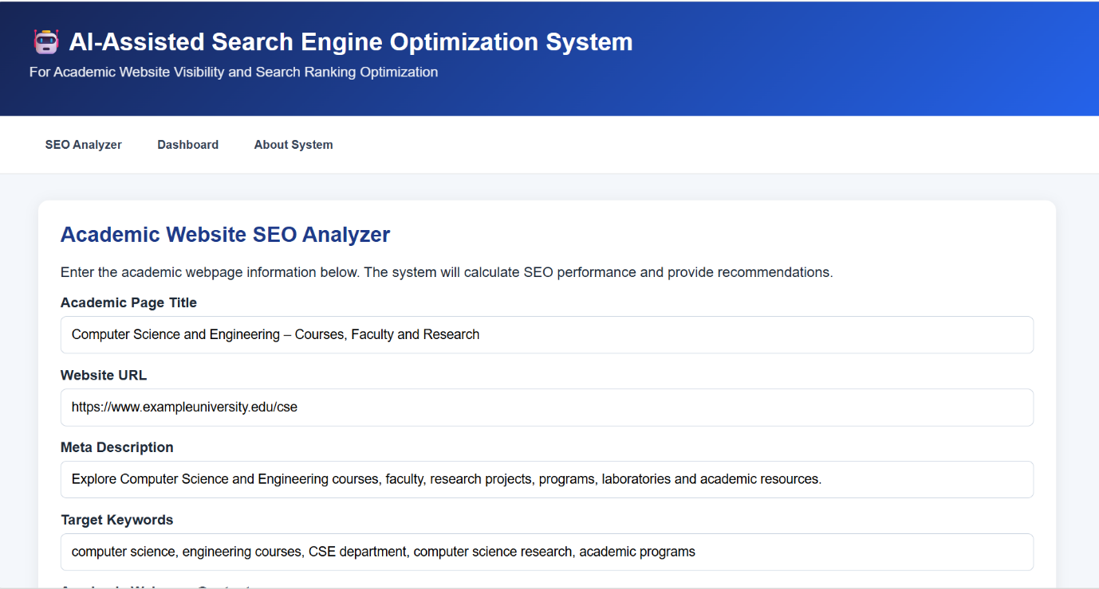
2 – Keyword, Title and Meta Optimization
Responsibilities:
- Keyword analysis
- Keyword effectiveness
- Title optimization
- Meta description generation
- SEO recommendations
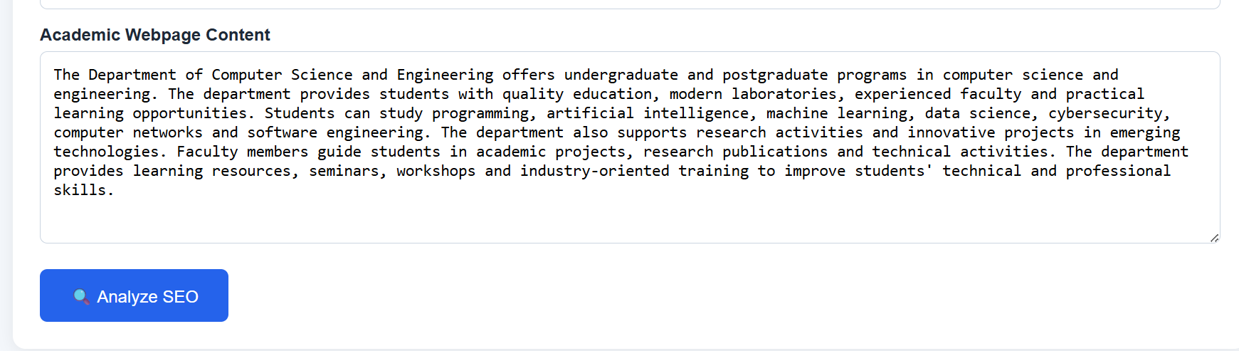
3 – Anchor, Structure and Sitemap Optimization
Responsibilities:
- Anchor-text analysis
- Webpage structure analysis
- Sitemap verification
- Structure optimization
- Final SEO re-evaluation
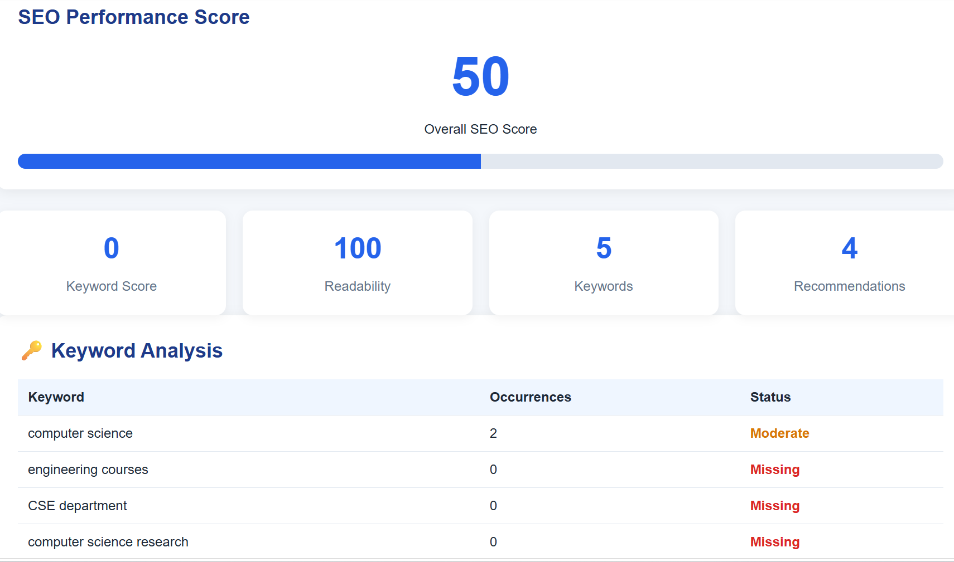
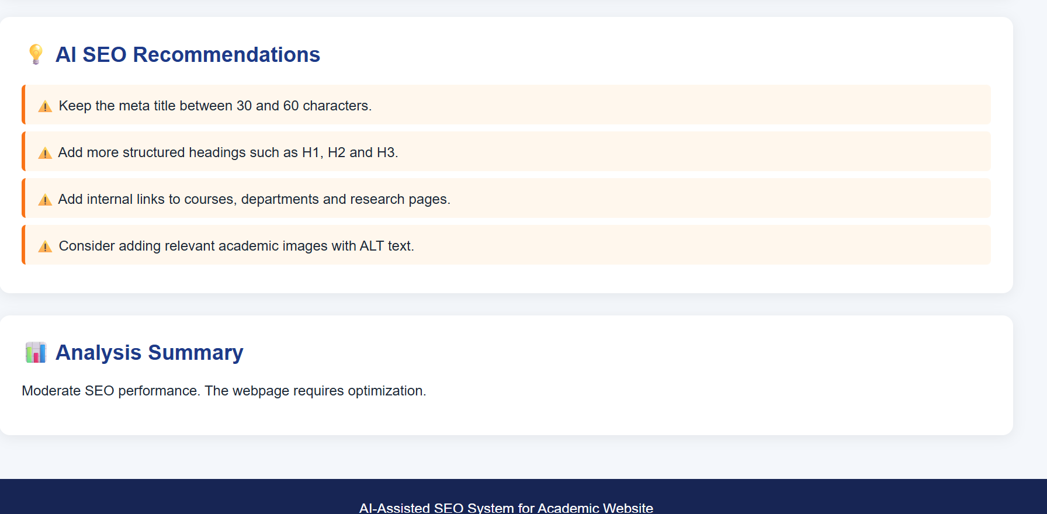

15. REFERENCES
- T. H. Cormen, C. E. Leiserson, R. L. Rivest and C. Stein, Introduction to Algorithms, MIT Press.
- C. D. Manning, P. Raghavan and H. Schütze, Introduction to Information Retrieval, Cambridge University Press.
- W. B. Croft, D. Metzler and T. Strohman, Search Engines: Information Retrieval in Practice.

